Methodology

EIB Climate Survey – 2022
Focus on African countries

Climate survey conducted by BVA for the European Investment Bank.

Survey conducted online (computer, tablet or mobile) from August 1st to August 25th 2022, in 10 African countries.
Respondents have been randomly selected among nationally representative panels. Panellists participate via self-administered web surveys.

Total sample of 6,105 people composed of 10 representative samples of the population aged 15 and over in each country.

The representativity of samples was ensured through the quota method and samples in each country were weighted according to gender, age and region.

The size of the representative citizen panel in each country is as follows:

Country | Sample size | Language used
Angola | 503 | Portuguese
Cameroon | 200 | English, French
Egypt | 1000 | Arabic
Ivory Coast | 500 | French
Jordan | 200 | Arabic
Kenya | 1000 | English
Morocco | 1000 | Arabic, French
Senegal | 202 | French
South Africa | 1000 | English
Tunisia | 500 | Arabic, French

Margin of error

This study presents results subject to the margins of error inherent in statistical laws. The table below shows the values of the margins of error (at the 95% level of confidence) according to the result obtained and the size of the sample considered.
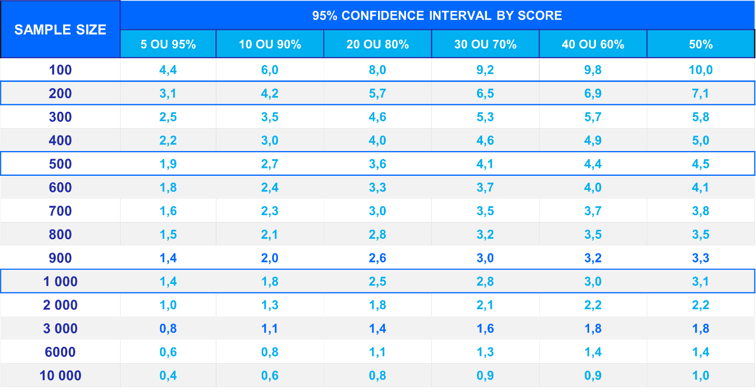

Example: For a sample of 1,000 respondents, for a survey percentage of 20%, the margin of error is 2,5. Therefore the percentage has 95% chance of being between 17,5% and 22,5%.

