EIB Climate Survey — fourth edition
LUXEMBOURG, 22 March 2022
Majority of Europeans confident that climate policies will improve their quality of life and create jobs

- 56% of Europeans believe climate policies are a source of economic growth
- 56% believe policies to tackle climate change will create more jobs than they eliminate
- 61% of Europeans think climate policies will improve their quality of life
- 25% fear they could lose their job because it will become incompatible with the need to mitigate climate change — this figure increases to 44% among people aged 20-29
- 66% feel that climate change will still be a serious issue by 2050

These are some of the results from the latest release of the 2021-2022 Climate Survey conducted in September 2021 and published today by the European Investment Bank (EIB). The EIB is the lending arm of the European Union and the world’s largest multilateral lender for climate action projects.
Better quality of life despite less purchasing power
Are policies to tackle climate change good news for the economy? Europeans are divided on whether the green transition will be a source of economic growth. 56% believe it will be the case, which is in line with the perception of Americans and British people (57%), while Chinese people are more optimistic (67%).
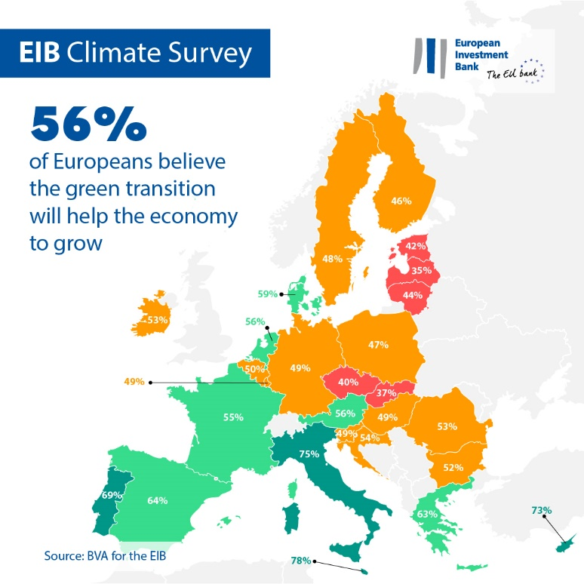
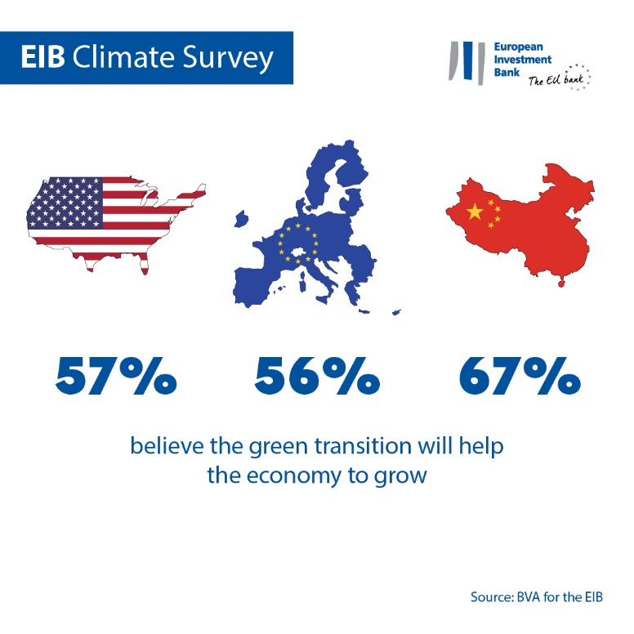
The majority of Europeans (61%) believe that their quality of life will improve, with greater convenience in their everyday lives and a positive impact on their food and their health. However, they are more pessimistic compared to Chinese people (77%), Americans (65%) and British people (63%). Policies that address the climate emergency are also seen as good news for the job market: 56% of Europeans say these will have a net positive impact on employment levels, creating more jobs than they eliminate.
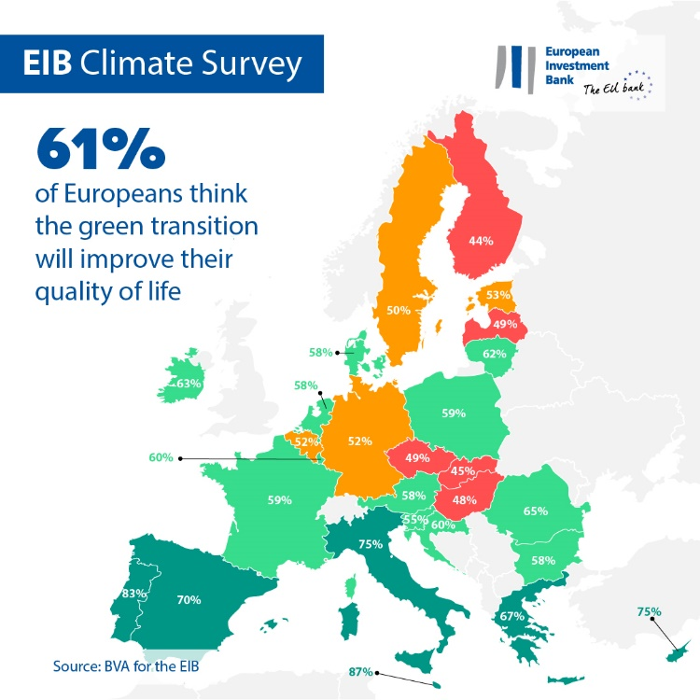
Looking closer at the western and eastern countries of the European Union, the results indicate that the majority of people living in eastern EU countries are rather pessimistic about the impact of climate policies on the job market. 55% fear that these policies will eliminate more jobs than they create. In contrast, 60% of people in western EU countries think that these policies will create more jobs than they eliminate.
Finally, two-thirds (62%) of Europeans anticipate that their purchasing power will decrease with the green transition.
Migration to other regions and changing jobs
According to Europeans, the challenges related to climate change are here to stay. While one-third (30%) believe that the climate emergency will be under control by 2050, 66% feel that it will still be a serious issue by mid-century.
European respondents say they see climate change threatening their place of residence. When asked about the longer-term impact of the climate crisis, one-third of the EU population (29%) expects to have to move to another region or country. This concern is much stronger among people aged 20-29, with 50% of them saying they are worried about the possibility of needing to move due to climate issues.
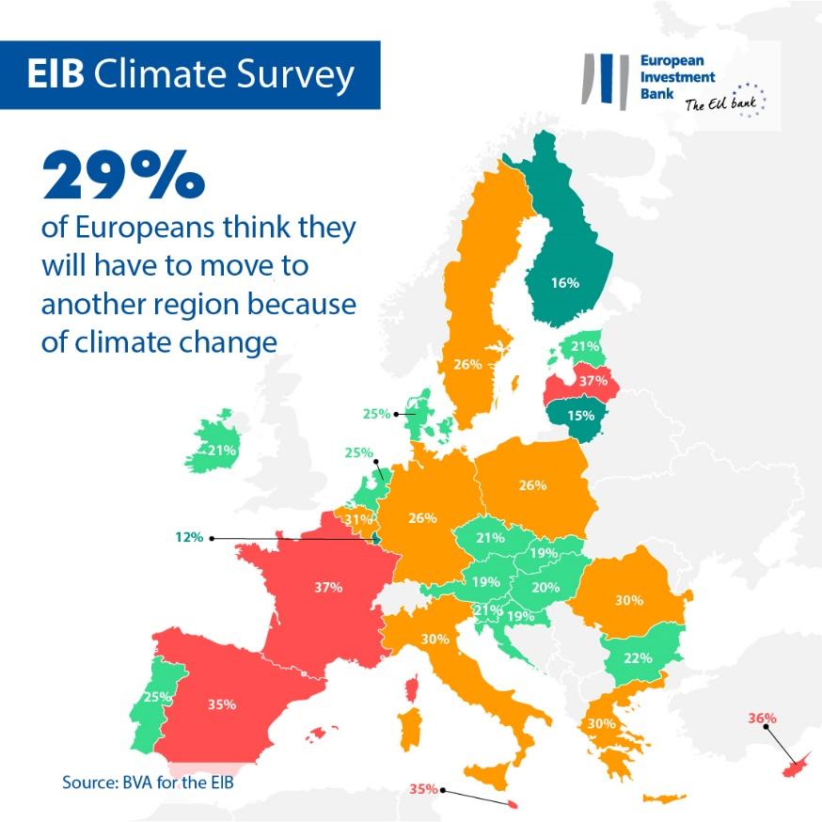
Young Europeans in particular are concerned about the sustainability of their jobs: almost half of respondents aged 20-29 (44%) fear they could lose their job because of its incompatibility with the fight against climate change (19 points above the EU average of 25%). This concern is even more evident among Chinese people (45%), Americans (32%) and British people (31%).
Lifestyle changes
Europeans are conscious of the behavioural shifts that are needed to tackle climate change. According to them, individual lifestyle changes that reduce carbon emissions will gain significant tractions in the next 20 years. One-third of respondents (32%) believe that most people will no longer own a car in 20 years and 63% say they think that most people will be working from home to contribute to the fight against climate change. Lastly, one-third (36%) think most people will have adopted a plant-based diet and 48% predict that an energy quota will be allocated to each individual.
EIB Vice-President Ambroise Fayolle said: “A majority of Europeans see the green transition as an opportunity to enhance their quality of life and create jobs. At the same time, they are concerned about the long-term consequences of climate change for them individually and for society as a whole. As the EU climate bank, we are working with the public and private sector to finance a green transition that is low-carbon and resilient, while ensuring we leave no one behind.”
Download the Excel spreadsheet with the raw data for all 30 countries surveyed here. Please click here to access a dedicated page on the EIB website presenting key findings of the EIB Climate Survey IV.
END

Media contact — Bruno Hoyer (b.hoyer@eib.org)
About the EIB Climate Survey
The European Investment Bank has launched the fourth edition of the EIB Climate Survey, a thorough assessment of how people feel about climate change. Conducted in partnership with market research firm BVA, the fourth edition of the EIB Climate Survey aims to inform the broader debate on attitudes and expectations in terms of climate action. More than 30 000 respondents participated in the survey between 26 August and 22 September 2021, with a representative panel for each of the 30 countries polled.
About the European Investment Bank
The European Investment Bank (EIB) is the long-term lending institution of the European Union and is owned by the EU Member States. It makes long-term finance available for sound investment in order to contribute towards EU policy goals both in Europe and beyond. The European Investment Bank is active in around 160 countries and is the world’s largest multilateral lender for climate action projects. The EIB Group has recently adopted its Climate Bank Roadmap to deliver on its ambitious agenda to support €1 trillion of climate action and environmental sustainability investments in the decade to 2030 and to deliver more than 50% of EIB finance for climate action and environmental sustainability by 2025. As part of the roadmap, all new EIB Group operations have been aligned with the goals and principles of the Paris Agreement since the start of 2021.
About BVA
BVA is an opinion research and consulting firm recognised as one of the most innovative market research firms in its sector. Specialised in behavioural marketing, BVA combines data science and social science to make data inspiring and bring it to life. BVA is also a member of the Worldwide Independent Network of Market Research (WIN), a global network of some of the world’s leading market research and survey players, with over 40 members.

