EIB Climate Survey — fourth edition
LUXEMBOURG, 1 February 2022
When shopping for a new car, two thirds of Europeans say they will opt for a hybrid or electric vehicle

The second part of the 2021-2022 EIB Climate Survey explores people’s views on climate change in a rapidly changing world. The results from this release focus on citizens’ individual behaviour and the actions they are taking to combat climate change.

- 78% of Europeans feel they are doing all they can to fight climate change in their daily lives, but the majority believe that their compatriots are not doing the same
- Only 33% of European car buyers say they will choose a petrol/diesel car next time they purchase a vehicle, while 67% say they will opt for a hybrid or electric vehicle
- 69% of young Europeans say they consider climate change when choosing a holiday destination. Yet the majority of them still plan to fly next summer
- 70% of Europeans say they take the issue of climate change into account when voting
- 54% of young Europeans consider climate change when looking for a job

These are some of the results from the second release of the 2021-2022 Climate Survey published today by the European Investment Bank (EIB). The EIB is the lending arm of the European Union and the world’s largest multilateral lender for climate action projects.
Hybrid and electric cars more sought after than petrol or diesel cars
When asked about future car purchases, 67% of European car buyers say they will either buy a hybrid or an electric vehicle. This figure is 34 points higher than the percentage of European car buyers who said they would buy a diesel or petrol vehicle (33%). More specifically, 39% would purchase a hybrid vehicle and 28% would opt for an electric vehicle.
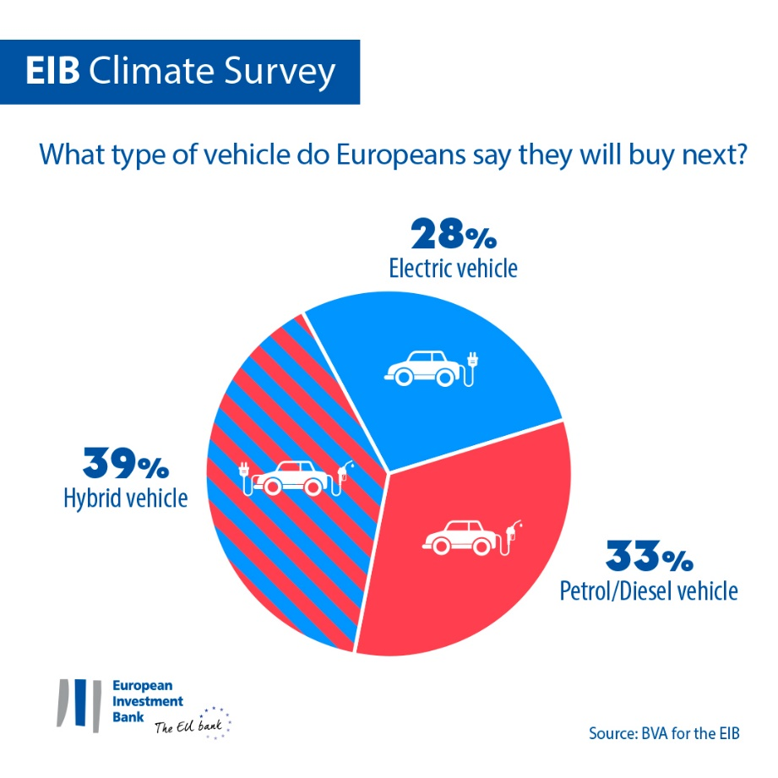

In general, European car buyers tend to favour hybrid vehicles (39%), while petrol or diesel vehicles are ranked second (33%) and electric cars come third (28% state they would purchase an electric car). While Chinese car buyers are the most inclined to buy an electric car (44%), Americans would opt first for a hybrid vehicle (38%), followed by a petrol or diesel vehicle (33%), then an electric car (29%).
Within the European Union, car buyers older than 65 are particularly interested in purchasing a hybrid vehicle (47%), while younger respondents (15-29 year-olds) consider a hybrid vehicle to be the least favourable option (31%). Young Europeans say they are slightly more likely to opt for a petrol or diesel vehicle (35%) or an electric car (34%) instead.
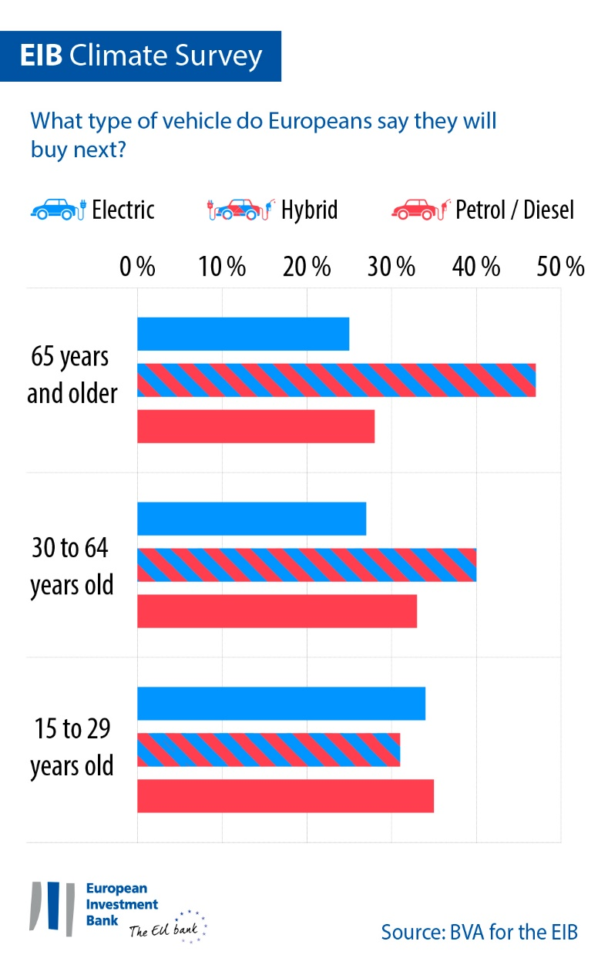

Only a minority of the overall EU population (13%) say they do not have a vehicle now and are not planning to buy one.
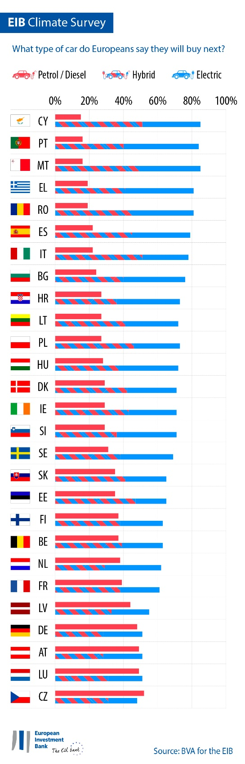
Climate protection versus flying for holidays
67% of Europeans say they consider climate change when choosing their holiday destination (nine points above the figure for Americans). This concern is even stronger amongst people younger than 30 (69% say they consider climate change when planning their holidays). However, a majority of young Europeans (52%, compared to 37% for people aged 30-64 and 25% for people aged 65 and above) say they will fly for their summer holidays in 2022. More than one-quarter of young people (27%, compared to 17% for people aged 30-64 and 12% for people aged 65 and above) say they will fly to a faraway destination.
Shopping for clothes, voting, deciding on a bank: how climate considerations affect people’s decisions
42% of Europeans say they already buy second-hand clothes instead of new ones. Women are more likely to do so than men (48% for women, 34% for men). This practice is particularly popular amongst 15-29 year-olds (54%), while the figure drops 26 points for people above 65 (28%).
Overall, 45% of Europeans consider climate change when they choose their bank or need to invest savings. This choice is stronger among Europeans between 15-29 year-olds (50%), but decreases with age (45% for the 30-64 year-olds and 40% for people above 65).
When it comes to voting, 70% of Europeans say they take climate change into account.
EIB Vice-President Ambroise Fayolle stated: “Despite some clear differences between age categories, Europeans are increasingly changing their mobility and consumption habits in a more responsible and sustainable manner to tackle climate change. These changes in individual behaviour show that people from all generations are willing to make stronger commitments in their daily lives to help mitigate the climate crisis. These desires have been voiced during COP26. They are a clear indicator that we need to further our efforts to support the green transition. As the EU climate bank, the role of the EIB is to finance innovative projects that provide practical and affordable solutions for more sustainable living and that will help build a decarbonised future for all.”
Download the Excel spreadsheet with the raw data for all 30 countries surveyed here. Please click here to access an EIB webpage presenting key findings of the EIB Climate Survey IV.
END

Media contact — Bruno Hoyer (b.hoyer@eib.org)
About the EIB Climate Survey
The European Investment Bank has launched the fourth edition of the EIB Climate Survey, a thorough assessment of how people feel about climate change. Conducted in partnership with market research firm BVA, the fourth edition of the EIB Climate Survey aims to inform the broader debate on attitudes and expectations in terms of climate action. More than 30 000 respondents participated in the survey between 26 August and 22 September 2021, with a representative panel for each of the 30 countries polled.
About the European Investment Bank
The European Investment Bank (EIB) is the long-term lending institution of the European Union and is owned by the EU Member States. It makes long-term finance available for sound investment in order to contribute towards EU policy goals both in Europe and beyond. The European Investment Bank is active in around 160 countries and is the world’s largest multilateral lender for climate action projects. The EIB Group has recently adopted its Climate Bank Roadmap to deliver on its ambitious agenda to support €1 trillion of climate action and environmental sustainability investments in the decade to 2030 and to deliver more than 50% of EIB finance for climate action and environmental sustainability by 2025. As part of the roadmap, all new EIB Group operations have been aligned with the goals and principles of the Paris Agreement since the start of 2021.
About BVA
BVA is an opinion research and consulting firm recognised as one of the most innovative market research firms in its sector. Specialised in behavioural marketing, BVA combines data science and social science to make data inspiring and bring it to life. BVA is also a member of the Worldwide Independent Network of Market Research (WIN), a global network of some of the world’s leading market research and survey players, with over 40 members.

